

Submitted by:
Name: Istiak Alam
ID: 05
Batch: 20
Lab report: 01
Date: 18.09.22
Course: CSE LAB
Course Code: 1202
Assignment Topic:
- Showing “Hello, world” in Output using C language
- Summation of any 2 numbers using C language
- Summation, Subtraction, Multiplication, Division of any 2 numbers using C language

Submitted to:
Nafisa Tabassum

LECTURER, NDUB

- Showing Hello World in output in using C language:

- Program:
//first program in c
#include <stdio.h>
//function main begins program execution
int main(void)
{
printf("Hello, World!!"); //print the statement
return 0; //indicate that program ended successfully
} //end function main
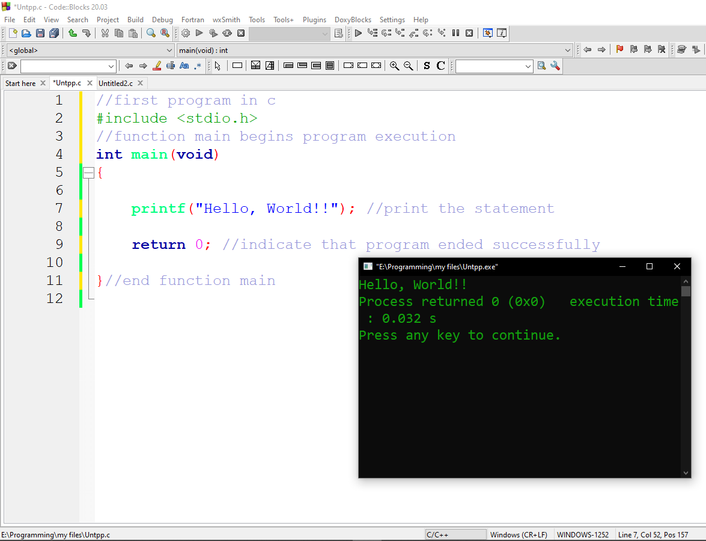
Figure 1.1 Program

- Output:
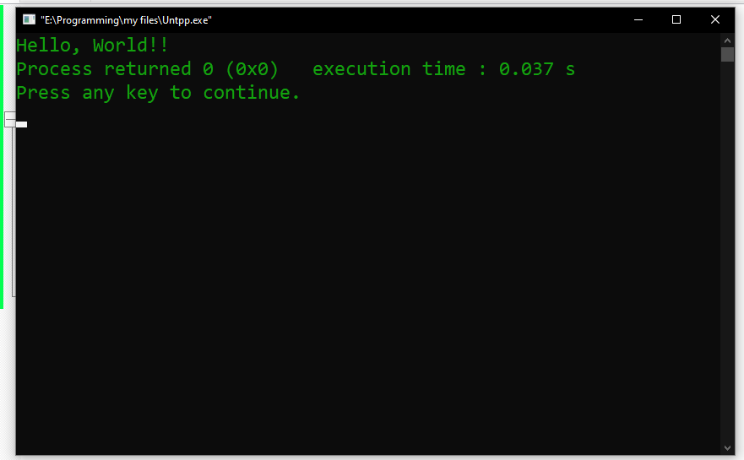
Figure 1.2 Output
- Description:
I begin by considering a simple C program in Figure 1.1
Begin with // indicating that these lines a comment, “first program in C”. I insert comments to document programs and improve program readability. My Comments do not cause the computer to perform any action when the program is run.
In the 1st line I used a comment for indicate the purpose of this code. In line 2 I used a library function called #include <stdio.h> which is a directive to the C preprocessor. In the 4th line the main function begins execute the program. In the main function int main (void) all the function were written enter in the curly brace {}.
In line 7 I use printf for showing “Hello, world” in the monitor. It indicates that printf is supposed to do something out of the ordinary. The output is also here, as we can see the output in Figure 1.2
In line 9 I indicate that the program ended successfully by using return 0;

- Summation of any 2 numbers using C language:

- Program:
//Summation of 2 numbers
#include <stdio.h>
//function main begins program execution
int main()
{
int x, y, sum; //assigning variables
printf("Enter your first number:\n"); //user prompt
scanf("%d", &x); //taking input from user
printf("Enter your 2nd number:\n"); //user prompt
scanf("%d", &y); //taking input from user
sum=x+y; //summation of 2 numbers
printf("The summation is:%d\n",sum); //showing output
return 0; //indicate that program ended successfully
} //end function main
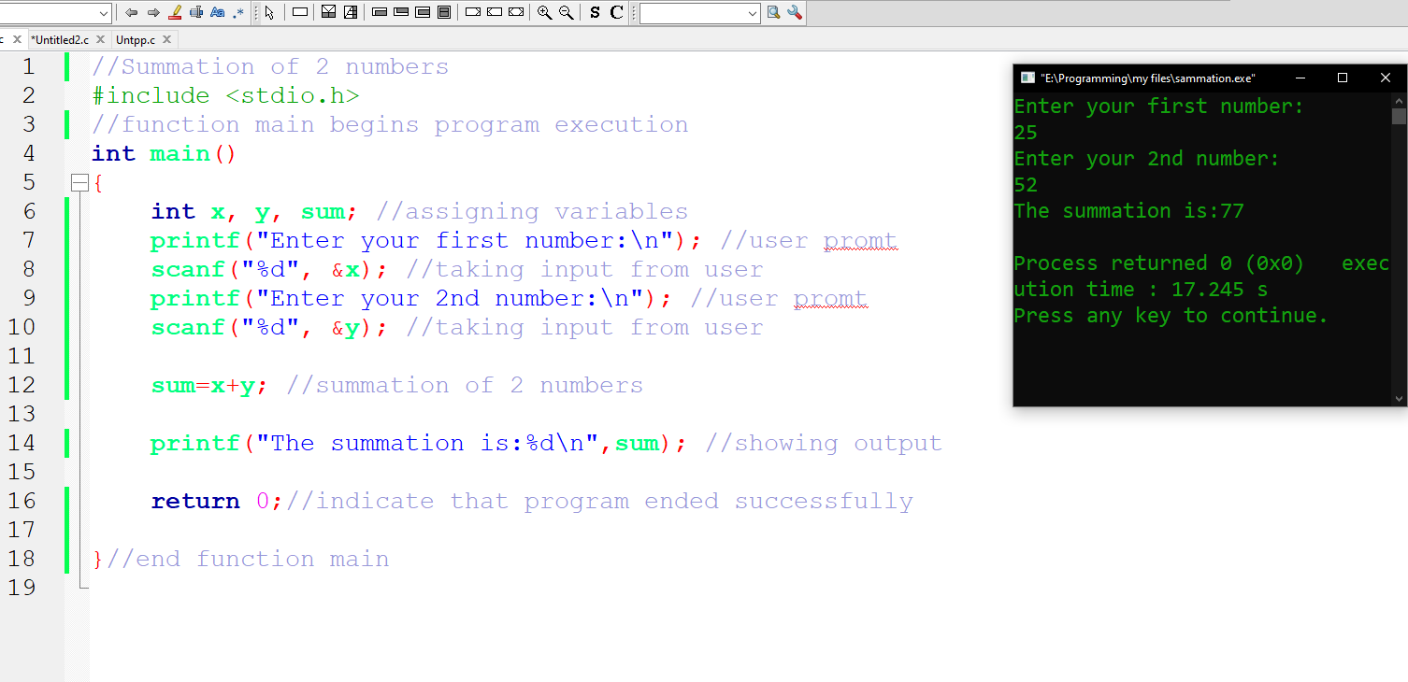
Figure 2.1 Program

- Output:
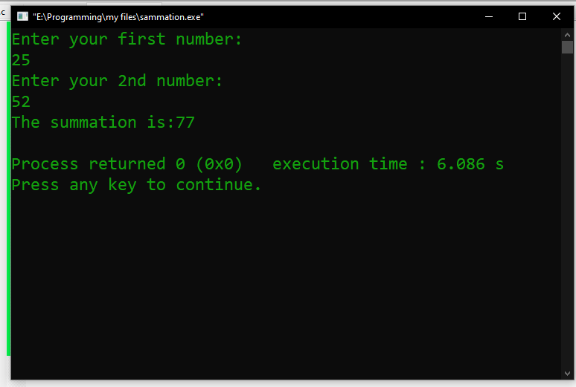
Figure 2.2 Output
- Description:
Begin with // indicating that this one line is a comment, “Summation of 2 numbers”. I insert comments to document programs and improve program readability. My Comments do not cause the computer to perform any action when the program is run.
In the 1st line I used a comment for indicate the purpose of this code. In line 2 I used a library function called #include <stdio.h> which is a directive to the C preprocessor. In the 4th line the main function begins execute the program. In the main function int main () all the function were written enter in the curly brace {}.
The names x, y and sum are the names of variables. In this program first of all I used int x, y, sum; This means that it needs to be worked on those variables. Then I used printf for user prompt, “Enter the first number”. Our next program uses the Standard Library function scanf to obtain two integers typed by a user at the keyboard, computes the sum of these values and prints the result using printf for showing “The summation” in the monitor. The output is also here, as we can see the output in Figure 2.2
In line 16 I indicate that the program ended successfully by using return 0;

- Summation, Subtraction, Multiplication, Division of any 2 numbers using C language

- Program:
//summation, subtraction, Multiplication, Division of 2 numbers
#include <stdio.h>
//function main begins program execution
int main()
{
int x, y, sum, sub, multi, div; //assigning variable
printf("Enter your first number:\n"); //user promt
scanf("%d", &x);//taking input from user
printf("Enter your 2nd number:\n"); //user promt
scanf("%d", &y);//taking input from user
sum=x+y; //summation of 2 numbers
sub=x-y; //subtraction of 2 numbers
multi=x*y; //multiplication of 2 numbers
div=x/y; //division of 2 numbers
printf("The summation is:%d\n",sum); //showing output
printf("The subtraction is:%d\n",sub);
printf("The multiplication is:%d\n",multi);
printf("The division is:%d",div);
return 0; //indicate that program ended successfully
}//end function main
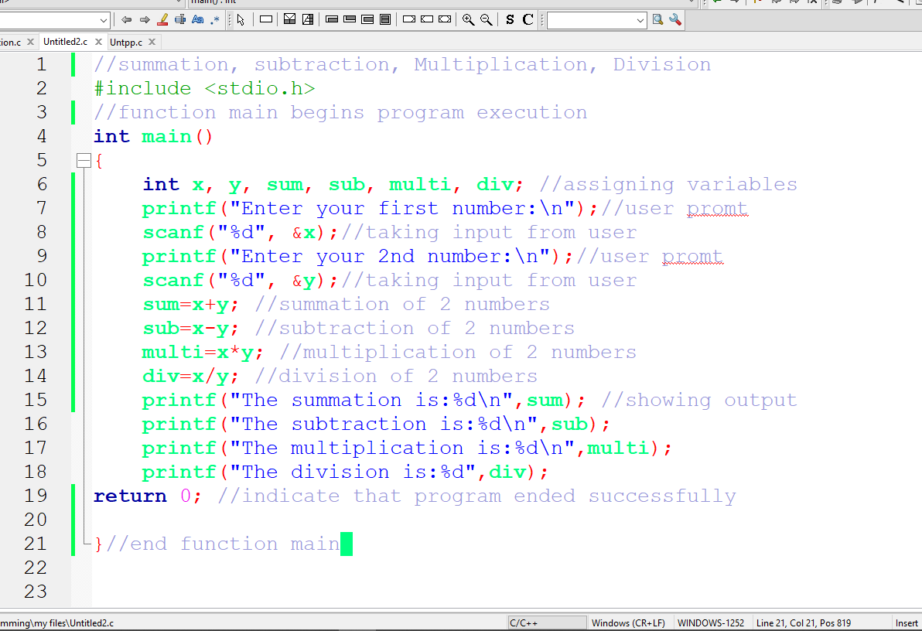
Figure 3.1 Program
- Output:
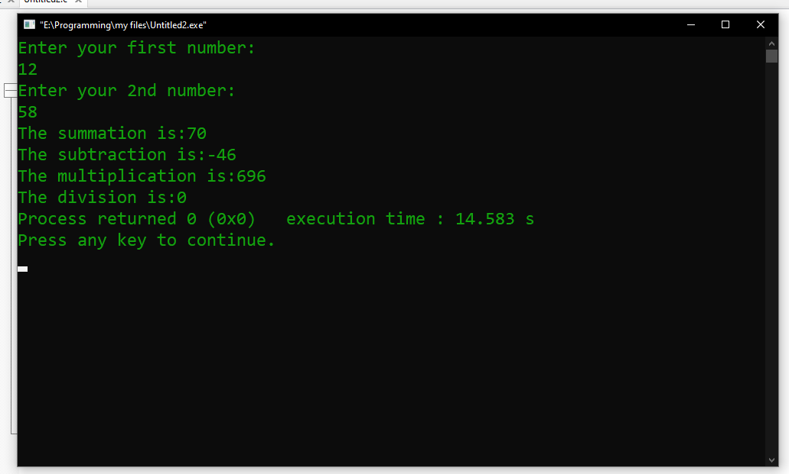
Figure 3.2 Output
- Description:
Begin with // indicating that this one line is a comment, “summation, subtraction, Multiplication, Division of 2 numbers”. I insert comments to document programs and improve program readability. My Comments do not cause the computer to perform any action when the program is run.
In the 1st line I used a comment for indicate the purpose of this code. In line 2 I used a library function called #include <stdio.h> which is a directive to the C preprocessor. In the 4th line the main function begins execute the program. In the main function int main () all the function were written enter in the curly brace {}.
The names x, y, sum, sub, multi, div are the names of variables. In this program first of all I used int x, y, sum, sub, multi, div; This means that, it needs to be worked on those variables. Then I used printf for user prompt, “Enter the first & second number”. Our next program uses the Standard Library function scanf to obtain two integers typed by a user at the keyboard, computes the sum of these values and prints the result using printf for showing the summation, subtraction, multiplication & division one by one in the monitor. In the line 11 to 14 those Summation, subtraction, multiplication, division functions are written for processes the integer values of x & y variables. After processing the value, the output is also here, as we can see the output in Figure 3.2
In line 19 I indicate that the program ended successfully by using return 0;

THE END

